 | IQVIATM Work Instruction Derived Datasets
Document Number and Revision:
CS_WI_BS013 Revision 15
Document Owner:  Carrie Eason | Author(s):  Stavros Drivas

PURPOSE
  - To describe the planning, production, review, delivery, documentation, and archival of derived datasets.

SCOPE
  - Applies to all projects globally where IQVIA Biostatistics uses SAS or non-SAS tools to:
    - Create derived variables and derived datasets
    - Manipulate data for statistical analyses, including the creation of Clinical Data Interchange Standards Consortium (CDISC) Study Data Tabulation Model (SDTM) and Analysis Data Model (ADaM) Datasets, which form the basis for the submission-ready datasets covered in CS_WI_BS022 Submission Deliverables.

ROLES AND RESPONSIBILITIES
The following roles perform tasks described within this Work Instruction:

Role | Sections
Statistical Team Lead (STL) | 6.1, 6.2, 6.4, 6.5, 6.6
Programming Team Lead (PTL) | 6.1, 6.2, 6.4, 6.5, 6.6
Programmer (Prog) | 6.2
Quality Control Reviewer (QC) | 6.1, 6.3
Senior Biostatistical Reviewer (SBR) | 6.1, 6.3
Biostatistics Project Team Member (BPTM) | 6.6

The Prog role refers to both Production and Quality Control Programmers.
The SBR role can be any qualified senior reviewer (statistician or programmer), except for key statistics and efficacy datasets requiring specific statistical knowledge.
The QC role can be any appropriate reviewer (statistician or programmer) who has the necessary QC knowledge and must be independent from the Production Programmer.

DEFINITIONS
Source data: Source data describes data transfers that Biostatistics receives from Data Management and other vendors. Such source data are understood to include Case Report Form (CRF) and non-CRF data.

Page 1 of 15
Copyright © 1999, 2000, 2003, 2006, 2008, 2010, 2012, 2013, 2015, 2017-2019, 2020, 2022 IQVIA. All rights reserved. The
contents of this document are confidential and proprietary to IQVIA Holdings Inc. and its subsidiaries. Unauthorized use, disclosure or reproduction is strictly prohibited.

MATERIAL AND EQUIPMENT
Not Applicable

PROCEDURE
The workflow diagrams for this work instruction are presented in Appendix A and B. The main steps involved in the creation of derived datasets are:
- Planning (including the creation, review and maintenance of derived dataset specifications)
- Production
- Review (including quality control)
- Delivery
- Documentation
- Archival
  - Planning
Derived dataset planning includes the creation, review and maintenance of derived dataset specifications.
The derived dataset specifications are created for each derived dataset (SDTM, ADaM or non-CDISC) to describe:
CDISC SDTM and ADaM Datasets, which form the basis for the submission- ready datasets (CS_WI_BS022 Submission Deliverables)
All derivations needed for planned analyses as described in the Statistical Analysis Plan and Table, Listing and Figure (TLF) Shells (see CS_WI_BS005 Statistical Analysis Plans (Covering Table Shells))
Structure of derived dataset(s)
Planned source data omissions from SDTM datasets with the associated reason for the omission

No: | Who: | Step: | When:
6.1.1 | STL/PTL | Determines if the following information is relevant to the planning of derived datasets and documents necessary information in the Biostatistics QC Plan (CS_TP_BS002):  - CDISC standards, which model(s), version(s) of the Implementation Guide(s) (IGs) (e.g. SDTM and/or ADaM) and Controlled Terminology (CT) are to be used  - Customer standards, which version(s) of customer standards are to be used (including checklist(s))  - Version(s) of coding dictionaries | Prior to planning derived datasets
6.1.2 | STL/PTL | Verifies the origin and format of source data to be used to create the derived datasets. | Prior to planning derived datasets

No: | Who: | Step: | When:
6.1.3 | STL/PTL | Creates the Tracking Document for Derived Datasets and Statistical Outputs (CS_TP_BS011) or applicable Biostatistics web-based solution/system. Creates a unique row for each derived dataset. | Before writing derived dataset specifications
6.1.4 | STL/PTL  (or delegate) | Produces the derived dataset specifications using the Derived Dataset Specification template (CS_TP_BS0208), equivalent document from the customer, SDTM Mapping Specification (CS_TP_BS0241), or specifications created with department tools (e.g. ADaM Spec Generator).  The production is guided by the following:  - Statistical Analysis Plan (SAP) and TLF Shells  - Annotated Case Report Form (aCRF)  - Vendor Data Transfer Guideline for non-CRF data  - CDISC and customer standards and instructions (may include the consideration of similar studies)  - SDTM Implementation Guide (IG)  - ADaM IG  - Relevant articles or literature  - Standardized macros or tools available from Biostatistics Innovation for improved efficiency and accuracy  - Global Biostatistics Derived Dataset Guidelines (such as DRAMA document available in the Biostatistics “General Guidelines and Template” folder in ELVIS)  - General and Trial Master File (TMF)-Specific Document Quality – Good Documentation Practices (CS_WI_RM0284) | During writing of derived dataset specifications
6.1.5 | STL/PTL  (or delegate) | Adheres to the following, unless they contradict relevant customer or CDISC standards:  - Derived dataset specifications are written in plain English, clear and concise  - Requirements are explained rather than providing SAS code on how to derive a variable  - Derived variables have unique names (i.e. the name is not the same as the “RAW” source variable name)  - Values of original Case Report Form (CRF) variables are not changed. If necessary, create a new variable (with a different variable name), change the value and retain the original variable  - Summary statistics data such as confidence intervals, p- values etc. are not included in derived dataset specifications (they are to be calculated in TLF programs, see Statistical Outputs CS_WI_BS014)  - All source datasets are cited in the SDTM derived dataset specifications. If a dataset is to be omitted, the dataset with the reason for the omission is to be included in an “Omission” domain in the derived dataset specifications with a reason. | During writing of derived dataset specifications

No: | Who: | Step: | When:
- Good Programming Practices documentation available under the Biostatistics Tools (Documentation folder) in ELVIS.
- Hard codes:
  - Only when requested and approved by the customer
  - Must be documented according to Good Programming Practices documentation
  - Must be documented in Hard Coding Approval Form (CS_FM_BS0243) if in effect after database lock
6.1.6 | STL/PTL | Recognizes potential complex derivations and/or issues by doing the following:  - Determine a method for flagging complex and/or key datasets in the Tracking Document for Derived Datasets and Statistical Outputs (CS_TP_BS011) or applicable Biostatistics web- based solution/system (e.g. color highlighting, utilizing the Comments sections, etc.)  - Identify derived datasets with complex and/or key derivations  - Clearly indicate any aspects of the specification that are pending additional information  If the specification writer has limited experience in the Therapeutic Area input from an experienced statistician/programmer should be considered. | Prior to derived dataset specifications review
6.1.7 | QC | Completes the derived dataset specifications Quality Gate Checks according to:  - Approaches to QC (CS_WI_BS015)  - Biostatistics QC Plan (CS_TP_BS002)  - Approaches to QC: Appendix G - Quality Gates for Derived Data Specifications and Sets (CS_OD_BS0227), Gate 1  - Verifies that all source datasets are accounted for in SDTM derived dataset specifications. An omitted source dataset should be documented in an “Omission” Specification with the associated reason for exclusion  - Documents completion in the Tracking Document for Derived Datasets and Statistical Outputs (CS_TP_BS011) or applicable Biostatistics web-based solution/system  Initiates discussion on derivations that need further clarification (as per Section 6.2.2). The team should take care to verify independence when discussing derivations as a group.  Documents any identified issues in the Tracking Document for Derived Datasets and Statistical Outputs (CS_TP_BS011), a Reviewer Feedback Form (RFF) (CS_FM_BS007) or an applicable Biostatistics web-based solution/system. | Before or at the time of programming the derived datasets

No: | Who: | Step: | When:
 |  | Note: Derived dataset specifications QC Review must be completed by any team member other than the author of the derived dataset specifications.
6.1.8 | SBR | Reviews the derived dataset specifications according to:  - Approaches to QC (CS_WI_BS015)  - Biostatistics QC Plan (CS_TP_BS002)  - Approaches to QC: Appendix G - Quality Gates for Derived Data Specifications and Sets (CS_OD_BS0227), Gate 2  Completes a Reviewer Feedback Form (CS_FM_BS007) or applicable Biostatistics web-based solution/system to document formal review.  Note: Any derived dataset specifications that will be excluded from SBR review must be documented in the QC Plan with associated reasons. Such exclusions are to be approved by the IQVIA customer oversight leader or business lead (exclusions must be due to customer relationship impact or other business reason).  Note: Major changes are protocol-specific changes that are considered related to the derivation of the critical data, i.e. data used for the analysis of the primary and secondary endpoints, data used for the selection of participants for analysis sets and other key data per the specific protocol. | Before Programming for derived datasets starts and after any major derived dataset specification changes
6.1.9 | STL/PTL  (or delegate) | Maintains the derived dataset specifications by making updates in accordance with any SAP updates or review comments:  - Reviews the modification history of the SAP to verify all applicable SAP updates are incorporated into the derived dataset specifications  - Repeats gate checks in Approaches to QC (CS_WI_BS015) related to modifications in the SAP and/or customer feedback on deliverables  - Documents changes to new versions of the derived dataset specifications in the “Modification History” section of the Derived Dataset Specification (CS_TP_BS0208), SDTM Mapping Specification (CS_TP_BS0241) or acceptable alternative  Note: See Approaches to QC (CS_WI_BS015) and Approaches to QC: Appendix G: Quality Gates for Derived Data Specifications and Sets (CS_OD_BS0227), Gate 1 (and Gate 2 for any major  changes), for further guidance. | During the production and review of derived datasets and ongoing through the production cycle.
6.1.10 | STL/PTL  (or delegate) | Implements version control for the derived dataset specifications. | After the derived dataset specifications

No: | Who: | Step: | When:
 |  |  | have been released for programming

  - Production of Derived Datasets
The production of a derived dataset requires the programming of the derived dataset by two independent programmers. The two datasets are then compared and reviewed per Section 6.3. The dataset creation steps listed below are completed by both programmers before moving on to the review step.

No: | Who: | Step: | When:
6.2.1 | STL/PTL | Assigns programmers to derived dataset production and enters programmer initials the Tracking Document for Derived Datasets and Statistical Outputs (CS_TP_BS011) or applicable Biostatistics web-based solution/system upon assignment. | Before starting derived dataset programming for each separate deliverable.
6.2.2 | Prog | Initiates a discussion with the author of the derived dataset specifications and the PTL if there are items that require further clarification to facilitate programming. If the PTL is the author, obtain additional input from STL | Before and ongoing during derived dataset programming
6.2.3 | Prog | Writes derived dataset programs based on the following:  - Derived dataset specifications  - Good Programming Practices documentation  - Current programming tools from Biostatistics Innovation available under the Biostatistics Tools in ELVIS  - Biostatistics Directory Structure | During derived dataset programming
6.2.4 | Prog | Identifies data issues that need to be resolved or explained and uses the Data Issues Log (CS_TP_BS014) or applicable Biostatistics web-based solution/system to communicate issues to the DTL (or designee).  Note: A single Data Issues Log (CS_TP_BS014) or applicable Biostatistics web-based solution/system should be used for communication and resolution of data issues throughout the life of  the study. | Ongoing during derived dataset programming
6.2.5 | Prog | Reviews each derived dataset (programmer’s review of their own work):  - Follows Approaches to QC (CS_WI_BS015)  - Follows Approaches to QC Appendices documents Appendix G: Quality Gates for Derived Data Specifications and Sets (CS_OD_BS0227), Gate 3  - Verifies that SAS logs are created for all SAS programs used in creation of derived datasets  - Shares unresolved warnings present in the SAS logs and warnings of a statistical nature with the STL and SBR for  further investigation | Before derived dataset is Ready for QC- ongoing

No: | Who: | Step: | When:
6.2.6 | Prog | Maintains the derived dataset programs in accordance with derived dataset specifications updates or review comments:  - Review the modification history of the derived dataset specifications to verify all applicable updates are incorporated into the derived dataset programs  - Repeat gate checks in Approaches to QC (CS_WI_BS015) related to modifications  - Document changes to new versions of the derived dataset specifications in the “Modification History” section of the programs once version control is implemented | During the production of derived datasets and ongoing through the production cycle.
6.2.7 | Prog | Updates and maintains the “Overall Status” in the Tracking Document for Derived Datasets and Statistical Outputs (CS_TP_BS011) or applicable Biostatistics web-based solution/system when the Quality Gate Checks are completed for each derived dataset | Ongoing during derived dataset programming
6.2.8 | Prog | Implements version control for the derived dataset programs when sent to a customer (internal or external) as part of a deliverable or in cases where the customer uses the created derived datasets | Ongoing during derived dataset programming

  - Quality Control of derived datasets
Before a derived dataset is ready for TLFs or delivery to the customer, the following reviews must be completed:
QC Review
Senior Biostatistical Review

No: | Who: | Step: | When:
6.3.1 | QC | Checks the derived datasets according to:  - Approaches to QC (CS_WI_BS015)  - Approaches to QC Appendices document, Appendix G: Quality Gates for Derived Data Specifications and Sets (CS_OD_BS0227), Gate 3 and 4  Updates the Tracking Document for Derived Datasets and Statistical Outputs (CS_TP_BS011) or applicable Biostatistics web-based solution/system when the Quality Gate Checks are completed for each derived dataset.  Documents any identified issues in the Tracking Document for Derived Datasets and Statistical Outputs (CS_TP_BS011), a RFF (CS_FM_BS007) or an applicable Biostatistics web-based solution/system. | Derived dataset is Ready for QC

No: | Who: | Step: | When:
6.3.2 | QC | Verifies that all source datasets are accounted for in the SDTM derived dataset SAS programs or that the dataset omission has been documented in an “Omission” Specification.  Updates the Tracking Document for Derived Datasets and Statistical Outputs (CS_TP_BS011) or applicable Biostatistics web-based solution/system when the reconciliation is complete.  Note: The source dataset and SAS program reconciliation checks will be performed using the Data Lineage and Export Comparison tool (DLEC). The tool produces an omitted data report. See DLEC Discussion Board for further guidance. | Before delivering derived datasets to customer
6.3.3 | SBR | Reviews derived datasets according to:  - Approaches to QC (CS_WI_BS015)  - Approaches to QC: Appendix G: Quality Gates for Derived Data Specifications and Sets (CS_OD_BS0227), Gate 5  Completes a Reviewer Feedback Form (CS_FM_BS007) or applicable Biostatistics web-based solution/system to document the review  Updates the Tracking Document for Derived Datasets and Statistical Outputs (CS_TP_BS011) or applicable Biostatistics web-based solution/system when the Quality Gate Checks are completed for each derived dataset.  Note: A major change in a derived dataset may differ from a major change in a derived dataset specification (per Section 6.1.8), such as when a significant proportion of data has become available since  a previous production cycle. | First draft derived datasets are ready for TLFs or delivery to the customer and for subsequent major changes to datasets

  - Delivery of Derived Datasets

No: | Who: | Step: | When:
6.4.1 | STL/PTL | Transfers the derived datasets to the customer as agreed, by adhering to Handling Data Transfers (CS_WI_BS020). | For every delivery

  - Documentation
Study team members involved in the production or review of derived datasets must store electronic files within the Biostatistics Directory Structure and/or in the eTMF as appropriate.

No: | Who: | Step: | When:
6.5.1 | STL/PTL | Obtains signatures for the Tracking Document for Derived Datasets and Statistical Outputs (CS_TP_BS011) and Reviewer Feedback Forms (CS_FM_BS007) or applicable Biostatistics web-based solution/systems from all study team members as applicable | As part of the delivery procedure.
6.5.2 | STL/PTL | Verifies that the “Deliveries” folder within the Biostatistics Directory Structure contains a complete back-up of:  - Derived dataset specifications (SDTM, ADaM or non- CDISC)  - Derived datasets (production and QC, SDTM, ADaM or non-CDISC)  - Programs, logs, output and LST files (production and QC, SDTM, ADaM or non-CDISC)  - Raw Data, External Data  - For each customer deliverable (SDTM, ADaM or non- CDISC excluding Dry Runs) the latest version of the Data Issue Log (CS_TP_BS014) or applicable Biostatistics web- based solution/system  - For SDTM dataset deliveries, the omitted data report, or equivalent documentation, confirming the reconciliation of source datasets versus the SDTM datasets  - Other applicable source material used such that the deliverable can be reconstructed at any time  Uses the appropriate department tools during delivery back-up creation, e.g. Snapshot Tool. | When delivering derived datasets to customer
6.5.3 | STL/PTL | Files the following documentation in the relevant folder(s) based on the TMF platform used:  - Final derived dataset specifications or a reference to their electronic location  - Final derived datasets and/or transport files or a reference to their electronic location  - Tracking Document for Derived Datasets and Statistical Outputs (CS_TP_BS011) or applicable Biostatistics web- based solution/system  - Reviewer Feedback Form or applicable Biostatistics web- based solution/system (CS_FM_BS007) and annotated comments (if applicable)  Note: See Trial Master File (TMF) (CS_OP_TMF0007) and Management and Filing of Biostatistics Documentation (CS_WI_BS0237) for further guidance. | After the delivery, within 30 days of finalization or on receipt

  - Archival

No: | Who: | Step: | When:
6.6.1 | STL/PTL | Delivers all final SAS programs necessary to produce derived datasets to the customer according to the Sending SAS Code to Customers Document | After final delivery of outputs
6.6.2 | BPTM | Copies final electronic files to the project directory. | Within six months of project completion
6.6.3 | STL/PTL | Archives the following for all deliveries (SDTM, ADaM or non- CDISC) in the TMF as per Trial Master File (TMF) (CS_OP_TMF0007) and Management and Filing of Biostatistics Documentation (CS_WI_BS0237):  - Final project files  - Final directory structure  - Interim deliveries | Within six months of project completion

- SUPPORTING DOCUMENTATION
DOCUMENT NUMBER | TITLE
ESOP References
7.1. CS_FM_BS007 | Reviewer Feedback Form
7.2. CS_FM_BS0243 | Hard Coding Approval Form
7.3. CS_OD_BS0227 | Approaches to QC: Appendix G: Quality Gates for Derived Data Specifications and Sets
7.4. CS_TP_BS002 | Biostatistics QC Plan
7.5. CS_TP_BS011 | Tracking Document for Derived Datasets and Statistical Outputs
7.6. CS_TP_BS014 | Data Issues Log
7.7. CS_TP_BS0208 | Derived Dataset Specification
7.8. CS_TP_BS0241 | SDTM Dataset Mapping Specifications
7.9. CS_WI_BS005 | Statistical Analysis Plans (Covering Table Shells)
7.10. CS_WI_BS014 | Statistical Outputs
7.11. CS_WI_BS015 | Approaches to QC
7.12. CS_WI_BS020 | Handling Data Transfers
7.13. CS_WI_BS022 | Submission Deliverables
7.14. CS_WI_BS0237 | Management and Filing of Biostatistics Documentation
7.15. CS_WI_RM0284 | General and Trial Master File (TMF) - Specific Document Quality – Good Documentation Practices
7.16. CS_OP_TMF0007 | Trial Master File (TMF)

DOCUMENT NUMBER | TITLE
Other References
7.17. Biostatistics General Guidelines | Good Programming Practices
7.18. Biostatistics General Guidelines | DRAMA guidelines
7.19. Biostatistics General Guidelines | Biostatistics Directory Structure
7.20. Biostatistics Tools Documentation | Sending SAS Code to Customers
7.21. Data Lineage and Data Comparison (DLEC) Tool | Data Lineage and Data Comparison (DLEC) Tool
7.22. Snapshot | Snapshot

- SUPERSEDES
DOCUMENT NUMBER | TITLE | REVISION NUMBER
8.1. CS_WI_BS013 | Derived Datasets | 14

- MODIFICATION FROM PREVIOUS REVISION
CHANGE | SECTION REFERENCE | JUSTIFICATION
Updated Author(s) and Document Owner | Title page | To reflect those responsible for the document
Text added to clarify the QC role requirements | Section 3.0 | For clarity
Vendor Data Transfer Guidelines for non-CRF data included as a document to be used in the production of derived dataset specification | Section 6.1.4 | Process clarification
Added references to SDTM Mapping Specification (CS_TP_BS0241) | Section 6.1.4 and 6.1.9 | SDTM Mapping Specification template to be used when creating SDTM specifications
Added SDTM and ADaM Implementation Guides into the documents to be used to guide the production of specifications | Section 6.1.4 | Process clarification
Use of Changes to Planned  Statistical Analyses Form (CS_FM_BS006) updated to be | Section 6.1.5 | New biostatistics form created to document hard codes

Hard Coding Approval Form (CS_FM_BS0243)
Detail added to describe how identified issues are documented | Section 6.1.7 and 6.3.1 | For clarity
Added Gate 3 into the checks the QC carries out | Section 6.3.1 | Process clarification
Added information relating to DLEC Discussion Board | Section 6.3.2 | To enable reader to seek further guidance, if required
Added references to Management and Filing of Biostatistics Documentation (CS_WI_BS0237) | Section 6.5 and 6.6 | For clarity
Additions made to the list of items to be included in the deliveries folder back-up creation | Section 6.5.2 | To be in line with the requirements in Management and Filing of Biostatistics Documentation (CS_WI_BS0237)
Added instruction to use the appropriate department tools during delivery back-up creation | Section 6.5.2 | Process clarification
Removed option for BPTM to send final electronic files to STL (or designee) | Section 6.6.2 | Process improvement
Various document links updated | Section 7.0 | Links not working
Updated references to the tracking document, RFF and data issues log to include “or applicable Biostatistics web- based solution/system” | Throughout | Biostatistics web-based solution/systems are being developed/ rolled out as a replacement for the tracking document, RFF and data issues log. Using either method is acceptable.
“Ensure” replaced with “Verify” | Throughout | For clarity
Lead Programmer (LP) updated to Programming Team Lead (PTL) | Throughout | Consistency of terminology across SOPs
Minor formatting updates | Throughout | For clarity

- APPENDICES

  - Appendix A: Derived dataset specifications workflow

  - Appendix B: Derived dataset workflow

Appendix A: Derived dataset specifications workflow

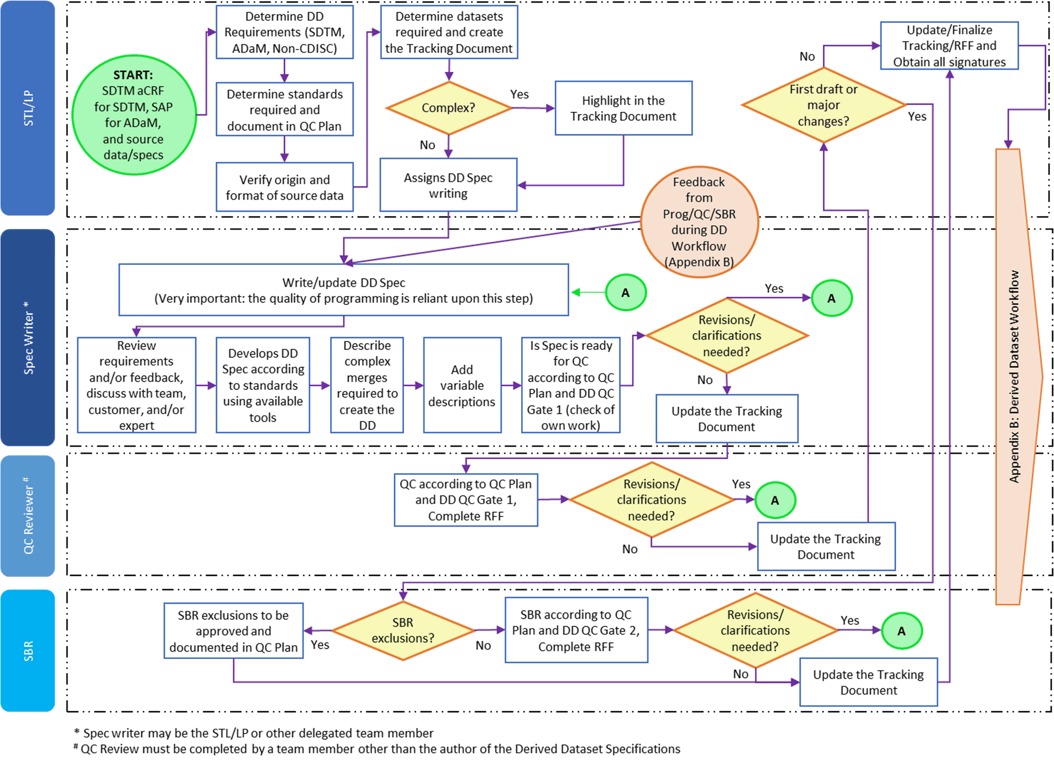

Appendix B: Derived dataset workflow

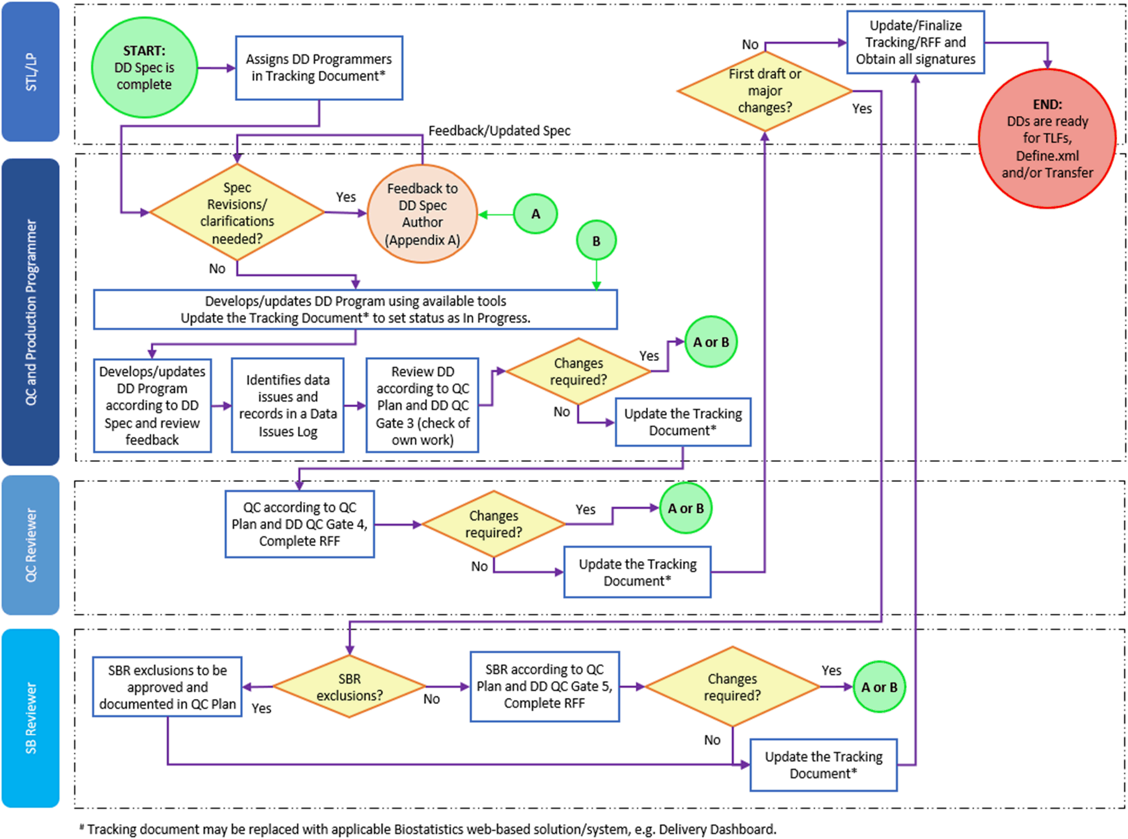

Page 15 of 15
Copyright © 1999, 2000, 2003, 2006, 2008, 2010, 2012, 2013, 2015, 2017-2019, 2020, 2022 IQVIA. All rights reserved. The
contents of this document are confidential and proprietary to IQVIA Holdings Inc. and its subsidiaries. Unauthorized use, disclosure or reproduction is strictly prohibited.

Standard Operating Procedure Approval Signature(s)
This is a representation of an electronic record that was signed electronically in Content Server.
This page is the manifestation of the electronic signature(s) used in compliance with the organization’s electronic signature policies and procedures
Refer to Signatories CV for Business Title.

UserName: Tebbenkamp, Greg (q460335) Title:
Date: Wednesday, 07 September 2022, 06:24 PM Eastern Daylight Time Meaning: Signing this Document Indicates My Approval
================================================

UserName: Bickford, Emma (q637065) Title:
Date: Monday, 12 September 2022, 01:24 PM Eastern Daylight Time Meaning: Signing this Document Indicates My Approval
================================================

UserName: Ranjan, Santosh (q723916) Title:
Date: Thursday, 15 September 2022, 08:38 AM Eastern Daylight Time Meaning: Signing this Document Indicates My Approval
================================================

